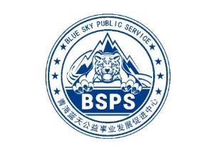
Disaster Emergency Response Capacity Improvement Training for Young Volunteers
Chengbei District, Xining City, Qinghai Province, China
From May 9th to May 10th, 2023
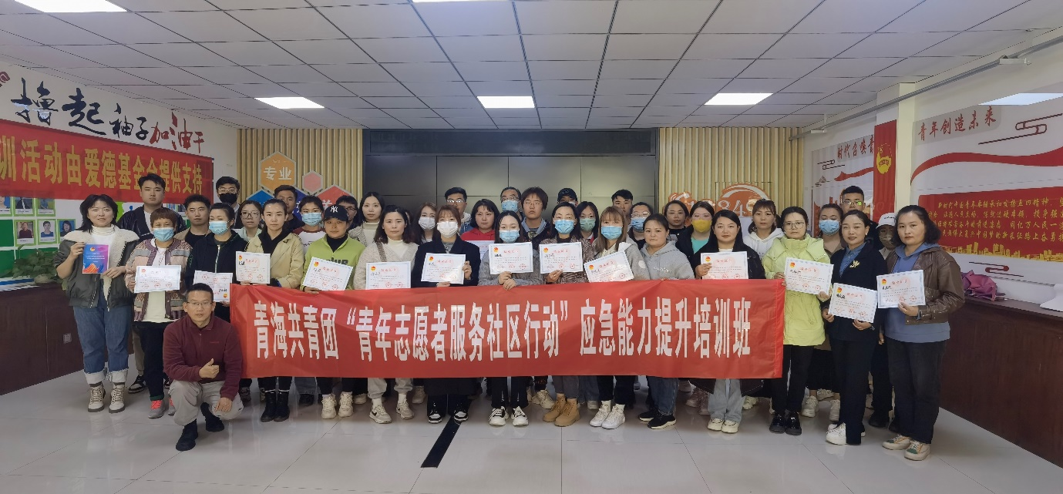
BACKGROUND
May 12 ,2023 is the fifteenth National Disaster Prevention and Mitigation Day, From May 6th to May 12th, China launched a nationwide publicity week on the theme of disaster prevention and mitigation "Preventing Disaster Risks and Escorting High-quality Development". This training is one of the activities carried out by Qinghai Blue Sky Public Service in Chengbei District and Chengdong District, Xining City, Qinghai Province, and the content of the activity is to learn the Sphere 2018 Chinese edition. The event is sponsored by the Amity Foundation. At the same time, another training session for young volunteers in the western and central districts of the city was held in Chenxi District, in which 213 young volunteers participated in the network through a webinar.
HOST
The Workshop was hosted by the Amity Foundation and the local partner organization Qinghai Blue Sky Public Service.
ABOUT THE AMITY FOUNDATION
The Amity Foundation, an independent Chinese social organization, founded in 1985 on the initiative of Chinese Christians led by Bishop K.H. Ting and joined by people from all walks of society, works to promote education, public health, social welfare, community development, environmental protection, disaster relief and other philanthropic undertakings in China and other parts of the world. Amity projects have benefited more than ten million people at home and abroad.
ABOUT QINGHAI BLUE SKY PUBLIC SERVICE
Qinghai Blue Sky Public Service (BSPS) was established in 2008 and officially registered with the Provincial Civil Affairs Department in 2017. It is the only authorized use organization of the "Blue Sky Rescue" brand in Qinghai province, formerly known as Qinghai Blue Sky Rescue Team.
BSPS has participated in Nepal earthquake, Myanmar flood, Yushu earthquake, Jiuzhaigou earthquake, Wuhan 2020 epidemic, 2021 Henan flood, and 2023 Turkey earthquake relief. At present, in addition to the implementation of disaster emergency response tasks, BSPS provides public services in the field of safety and health, such as disaster prevention and mitigation, emergency response capacity improvement, safety self-protection education, forest and grass fire prevention, safety production, ecological environmental protection, youth development, and safety guarantee for events and activities.
PARTICIPATION
Lead Facilitator: LEI, Guangqing
Cofacilitator: WANG, Kaibo
Trainee: 48 Young Volunteers come from Chengbei District and Chengdong District
Goals/learning objectives:
- Proficiency in Sphere 2018 Chinese.
- Apply the Sphere 2018 Chinese to design humanitarian relief projects.
AGENDA
 | May 9th | May 10th
Morning Session | Introduction to Sphere | WASH & Health
Morning Session | CHS and The Code of Conduct | Food Security and Nutrition
Morning Session | Sphere and the Programme Cycle | Shelter and Settlement
Afternoon Session | Sphere, Cash and Markets | Using Technical Standards and Indicators
Afternoon Session | Humanitarian Aid Project Evaluation and Design Practices | Evaluation and Wrap-Up
In the morning of May 11, after a brief introduction, the facilitators first conducted a pre-test of the common sense of humanitarian aid for the trainees, and the pre-test found that the trainees understanding of the relevant standards was very low, with a total of 15 questions and 10 points per question, and the average score of the trainees was only 40 points.

Test QR codes online
The first day of the workshop was divided into 7 groups, two for learning and discussing WASH, two for food security and nutrition, and the rest for Shelter and Settlement. The next day, it was reassigned to 6 groups, each with participants who had studied WASH, Food Security and Nutrition, and Shelter and Settlement the day before.
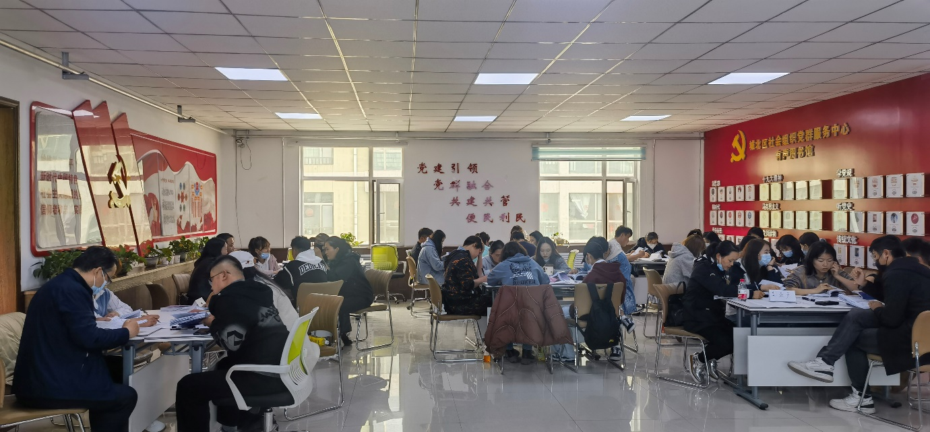
The first day was divided into 7 study groups to study and discussion different chapters.
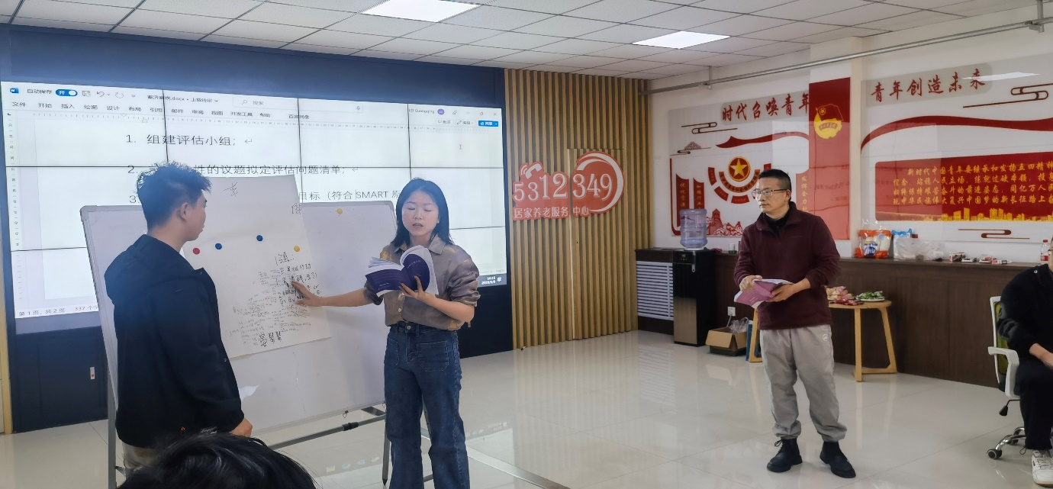
The Pineapple Group shared case discussions on CHS and project cycle.
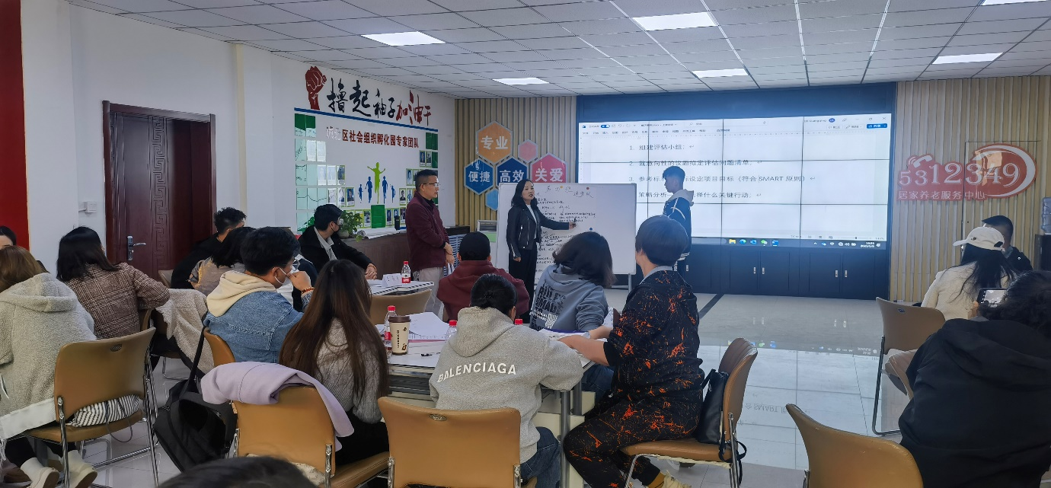
The Dream Chasing Group shared the evaluation and design of food security and nutrition projects.
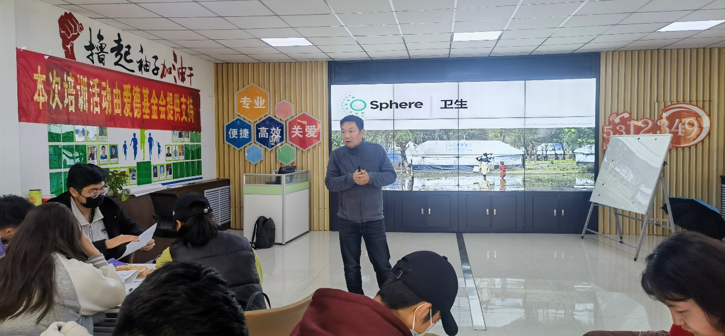
Cofacilitator: WANG, Kaibo teaches the Health chapter.
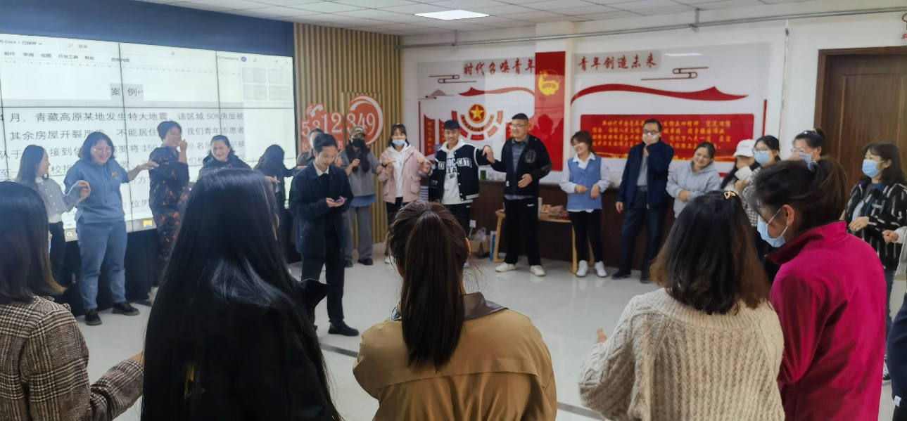
Games
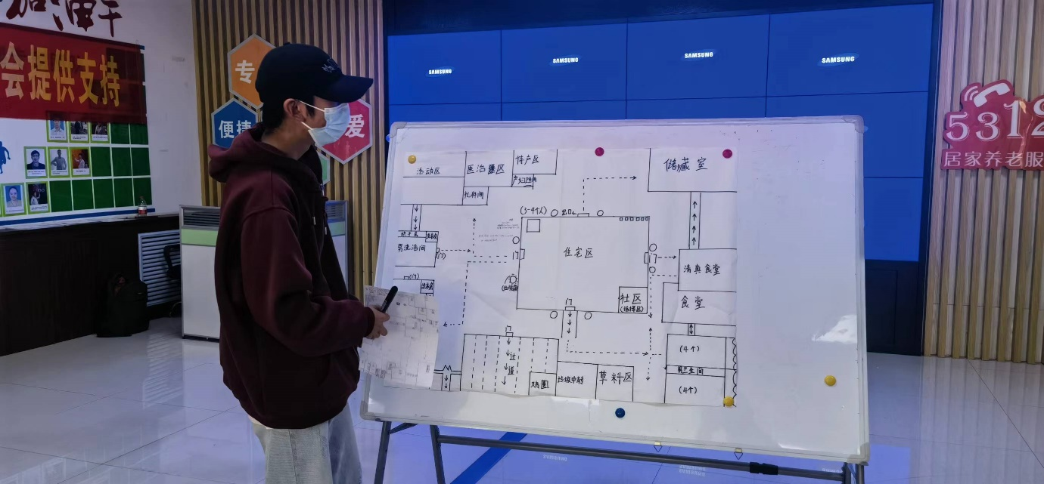
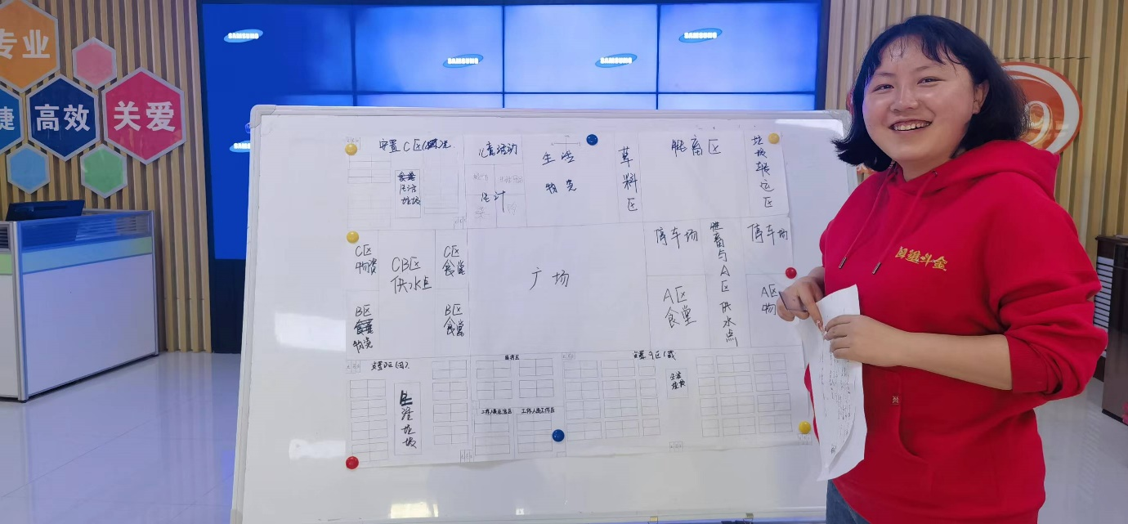
The teams report on camp settlement programmes and project plans.
SUMMARISED PARTICIPANT SURVEY RESULTS:
Final evaluation was conducted at the course closure:
- 42 out of 48 participants rated “Very Good” in the “Overall Rate”, “Design & Structure” and “Presentation and Facilitation”. Others 6 rated “Good”.
- 35 out of 48 considered t Shelter and Settlement to be the most important.
BEST PRACTICES:
- Different groups study different chapters and then share them, which is the most efficient learning.
- Regrouping in the second day allows each group to quickly familiarize themselves with the chapters they didn't learn on the first day
- Practice is the best teacher.

CONCLUSIONS
This workshop improved the ability of young volunteers to design humanitarian relief projects in Chengbei district and Chengdong district, Xining City, and all learning groups completed the camp settlement design with high quality. Later tests showed that the average score of trainees increased than 75 points; This training tried the young volunteer system to promote the Sphere and achieved good results, effectively improving the level of designing humanitarian aid projects in the Chengbei District and Chengdong District Xining City. Together with the webinar and another training in the Chenxi District of the city, BSPS completed the Sphere training for a cadre of young volunteers across the province, and in the future, Qinghai Blue Sky Public Service will be committed to promoting Sphere in Qinghai.
ACKNOWLEDGEMENTS:
Thanks to Oxfam Hong Kong for arranging a programme officer who is familiar with Sphere to facilitate this training.

