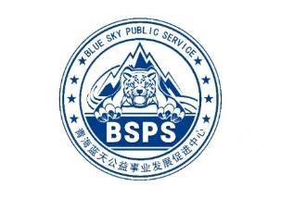
Disaster Emergency Response Capacity Improvement Training for Government Staff
Chengzhong District, Xining City, Qinghai Province, China
From May 11st to May 12nd, 2023
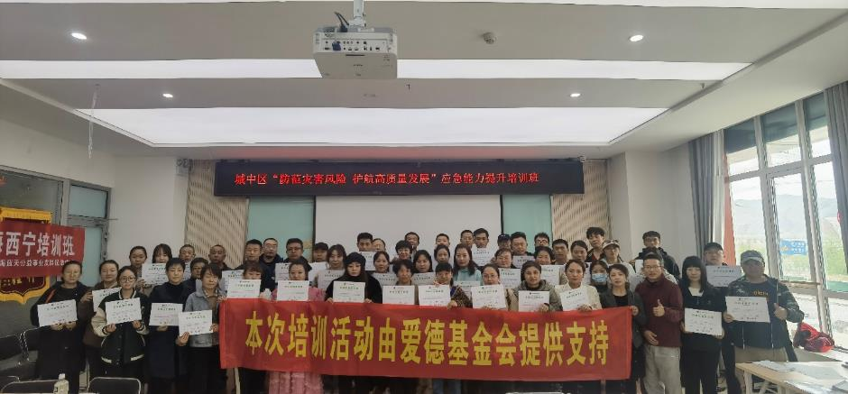
BACKGROUND
May 12, 2023 is the fifteenth National Disaster Prevention and Mitigation Day, From May 6th to May 12th, China launched a nationwide publicity week on the theme of disaster prevention and mitigation "Preventing Disaster Risks and Escorting High-quality Development". This training is one of the activities carried out by Qinghai Blue Sky Public Service in Chengzhong District, Xining City, Qinghai Province, and the content of the activity is to learn the Sphere 2018 Chinese edition. The event is sponsored by the Amity Foundation.
HOST
The Workshop was hosted by the Amity Foundation and the local partner organization Qinghai Blue Sky Public Service.
ABOUT THE AMITY FOUNDATION
The Amity Foundation, an independent Chinese social organization, founded in 1985 on the initiative of Chinese Christians led by Bishop K.H. Ting and joined by people from all walks of society, works to promote education, public health, social welfare, community development, environmental protection, disaster relief and other philanthropic undertakings in China and other parts of the world. Amity projects have benefited more than ten million people at home and abroad.
ABOUT QINGHAI BLUE SKY PUBLIC SERVICE
Qinghai Blue Sky Public Service (BSPS) was established in 2008 and officially registered with the Provincial Civil Affairs Department in 2017. It is the only authorized use organization of the "Blue Sky Rescue" brand in Qinghai province, formerly known as Qinghai Blue Sky Rescue Team.
BSPS has participated in Nepal earthquake, Myanmar flood, Yushu earthquake, Jiuzhaigou earthquake, Wuhan 2020 epidemic, 2021 Henan flood, and 2023 Turkey earthquake relief. At present, in addition to the implementation of disaster emergency response tasks, BSPS provides public services in the field of safety and health, such as disaster prevention and mitigation, emergency response capacity improvement, safety self-protection education, forest and grass fire prevention, safety production, ecological environmental protection, youth development, and safety guarantee for events and activities.
PARTICIPATION
Lead Facilitator: LEI, Guangqing
Co-facilitator: CUI, Yazhou
Trainee Trainer: WANG, Kaibo
Trainee：55 (including 41 grassroots government workers and 14 members of the Qinghai Blue Sky Rescue Team)
GOALS & LEARNING OBJECTIVES
- Proficiency in Sphere 2018 (Chinese edition);
- Apply the Sphere 2018 (Chinese edition) to design humanitarian relief projects.
AGENDA
 | May 11st | May 12nd
Morning Session | Introduction to Sphere | WASH
Morning Session | CHS and The Code of Conduct | Food Security and Nutrition
Morning Session | Sphere and the Programme Cycle | Shelter and Settlement
Afternoon Session | Sphere, Cash and Markets | Using Technical Standards and Indicators
Afternoon Session | Humanitarian Aid Project Evaluation and Design Practices | Evaluation and Wrap-Up
In the morning of May 11, after a brief introduction, the facilitators first conducted a pre-test of the common sense of humanitarian aid for the trainees, and the pre-test found that the trainees' understanding of the relevant standards was very low, with a total of 15 questions and 10 points per question, and the average score of the trainees was only 45 points.

Test QR codes online
The workshop was divided into four groups, each with three teams, to discuss and learn different chapters, and finally cooperate to complete the design of humanitarian relief projects in disaster scenarios.
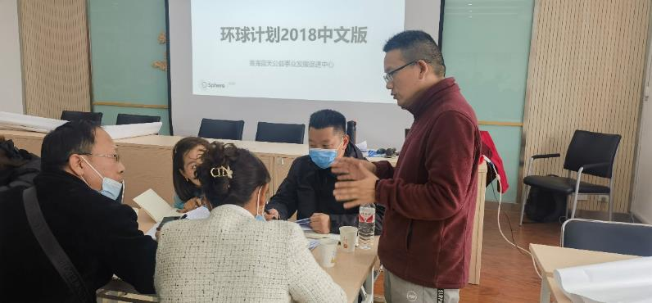
Collaborator LEI Guangqing answered questions for the trainees.
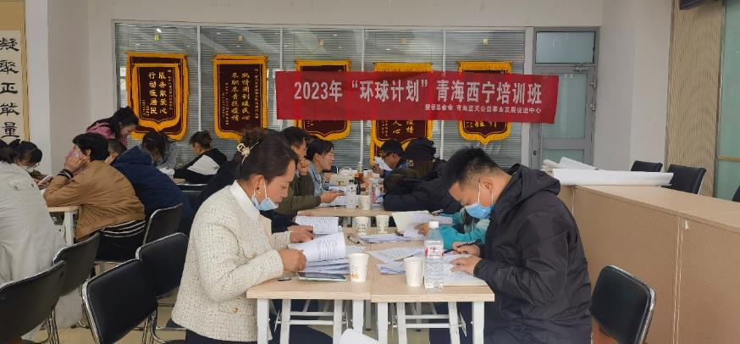Trainees discuss in groups how to design humanitarian aid projects.
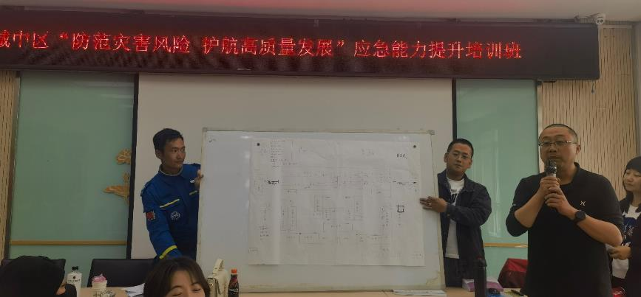
The Qinghai Blue Sky Rescue Team share the camp resettlement plan.
SUMMARISED PARTICIPANT SURVEY RESULTS
Final evaluation was conducted at the course closure:
- 40 out of 55 participants rated “Very Good” in the “Overall Rate”, “Design & Structure” and “Presentation and Facilitation”. Others 11 rated “Good”.
- 38 out of 55 considered the application of the Programme Cycle in humanitarian assistance programmes to be the most important.
BEST PRACTICES
- Different groups study different chapters and then share them, which is the most efficient learning.
- Mastering the structure of the standard can effectively improve the familiarity with the Sphere.
- Practice is the best teacher.
CONCLUSIONS
This workshop improved the ability of grassroots government staff and Qinghai Blue Sky Rescue Team to design humanitarian relief projects in Chengzhong district Xining City, and all learning groups completed the camp resettlement design with high quality. Later tests showed that the average score of trainees increased than 80 points; This training tried the government system to promote the Global Plan and achieved good results, effectively improving the level of designing humanitarian aid projects in the Xining City District, and in the future, Qinghai Blue Sky Public Service will be committed to promoting Sphere in Qinghai.
ACKNOWLEDGEMENTS
Thanks to Oxfam Hong Kong for arranging a programme officer who is familiar with Sphere to facilitate this training.

