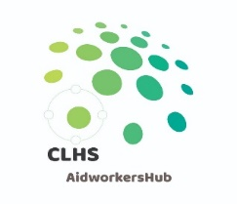



1-Day Sphere Training Program
DanChurchAid, Bulawayo
September 2021
Facilitator: Pearson Marasha, Sphere Country Focal Point, ZW
Co-facilitator: Tobias Ndlovu, Global Humanitarian Advisor, DCA

Day 1: | Guiding Principles
Time | Session
8:00–8:30 | Arrival and Welcome (brief introductions, ground rules, overview, and objectives)
8:30–10:00 | STP 3: What is Sphere – Standards in Context
10:00–10:30 | Coffee break
10:30–12:00 | STP 4: The Humanitarian Charter
12:00–13:00 | Lunch
13:00–14:30 | STP 5: Protection Principles
14:30–15:00 | Coffee break
15:00–16:30 | STP 6: Core Humanitarian Standard

